KD Module 5: Teacher Professional Development

Unit 2: Life Long Learning II

Objectives:
Pre-service teachers use ICT to access outside experts and learning communities to support their activities and their own professional learning (KD.6.b).
Duration: Total of 5 notional hours –1 hour lecture, 3 hour computer practical session and 1 hour self-study (preferably at a computer).

A] Lecture Content (1 hour)

Notes to Lecturer
Introduce students to the concept of Personal Learning Networks and the various sources and experts that are available to them online to help them further their professional learning. The following introductory passage has been provided as a guide only. You may refer to the following resources for background reading:
- Creating a PLN: http://teacherchallenge.edublogs.org/challenges-2/creating-a-pln/
- Presentation: Creating a Personal Learning Network #PLN: http://www.dontwasteyourtime.co.uk/presentations/presentation-creating-a-personal-learning-network-pln/
- PLN: Your Personal Learning Network Made Easy: http://onceateacher.wordpress.com/2009/05/05/pln-your-personal-learning-network-made-easy/

Introduction
An important part of learning is to build your own Personal Learning Network (PLN) – a group of people who can guide your learning, point you to learning opportunities, answer your questions and give you the benefit of their own knowledge and experience.

What exactly is a PLN?
In his article, “Grow Your Personal Learning Network: New Technologies Can Keep You Connected and Help You Manage Information Overload”, David Warlick describes a Personal Learning Network as follows:

“Personal learning networks (PLNs) are not new. We have long relied on our families, friends, colleagues, and acquaintances to supplement our knowledge about the world. Our professional learning also comes from reference books, the textbooks we carried home from college, the television and radio stations we tune in to, and the professional and personal-interest periodicals to which we subscribe. And we have been connecting with people and information through the digital realm for decades. But the times are still changing. Information and communication technologies (ICT), including an ever-growing repertoire of open source applications, have freed content from the printed page, giving voice to the ideas of people we have never had access to before and enabling us to reshape our information experiences to suit our learning needs. Harnessing these new technologies to create and grow our own PLNs is imperative for educators who want to stay connected to the changing world we are charged with introducing to our students.”

Personal Learning Networks enable teachers and student teachers access to a wide range of experts and communities to support their professional learning. This can be facilitated through the use of a range of ICT tools, some of which include professional learning communities and websites, social networking sites (Facebook, Twitter, LinkedIn), social bookmarking tools (Diigo, Delicious), wikis (wetpaint, Wikispaces) and MOOCs (Massive Open Online Course).
Essentially, anyone that you interact with, whether they are social contacts, professional peers or experts in their field, can be considered part of your Personal Learning Network.
Warlick goes on to describe three main types of PLNs:

- Personally maintained synchronous connections. This is the traditional network that includes the people and places you consult to answer questions, solve problems and accomplish goals. Today, however, you can enhance this PLN with new tools such as chat, instant and text messaging, teleconferencing (using iChat, Skype, uStream), Twitter, and virtual worlds such as Second Life. It’s like attending a meeting at work, only better, because the traditional barriers of geography, background, language and culture become transparent.
- Personally and socially maintained semi-synchronous connections. For networked learners, these are conversations that are not exactly conversations. They may be questions directed toward a single friend or associate, but more likely they are sent out to a community of people who, because of their interests, expertise, or perspectives, are in a position to help you do your job. Semisynchronous refers to the idea that collaboration doesn’t have to happen in real time. Not only can the collaborators be geographically distant, but they can also participate in a discussion when it works best for their schedules, regardless of time zones or office hours. The tools you can use to build and grow this type of network include mailing lists, wikis, Google Docs, Twitter, group discussion boards and comment walls in Facebook, and commenting on blogs, among others.
- Dynamically maintained asynchronous connections. The first two types of PLN connect us with each other, but this type more often connects us with content sources that we have identified as valuable. The central tool for dynamically maintained asynchronous connections is the RSS aggregator. Aggregators such as Google Reader, Netvibes and Pageflakes are now at the core of many educators’ PLNs because they bring us information that helps us do our jobs. In a sense, this technology has inspired a shift from a hunting and gathering information economy to the domestication of the information landscape. When you subscribe to tagged Flickr photos, new videos from YouTube or TeacherTube, Google News searches or podcasts, you are training all this information to organise and deliver itself to you. For example, after finding an education blog through a blog search on Technorati, you can subscribe to its RSS feed with your aggregator. Then you can sit back and relax, waiting for the software to periodically check for new posts, retrieve them as they appear and make them available for reading at your leisure. You can also subscribe to ongoing blog searches that will scan the entire blogosphere and automatically send to you new posts on your chosen topic. Some of the most useful PLN tools are social bookmarking services such as Delicious. As people add new websites to their online bookmarks and categorise or tag them, that information becomes available to the entire community.

Figure 1: The networked learner receives information from various sources and in turn becomes a source for others’ PLNs.
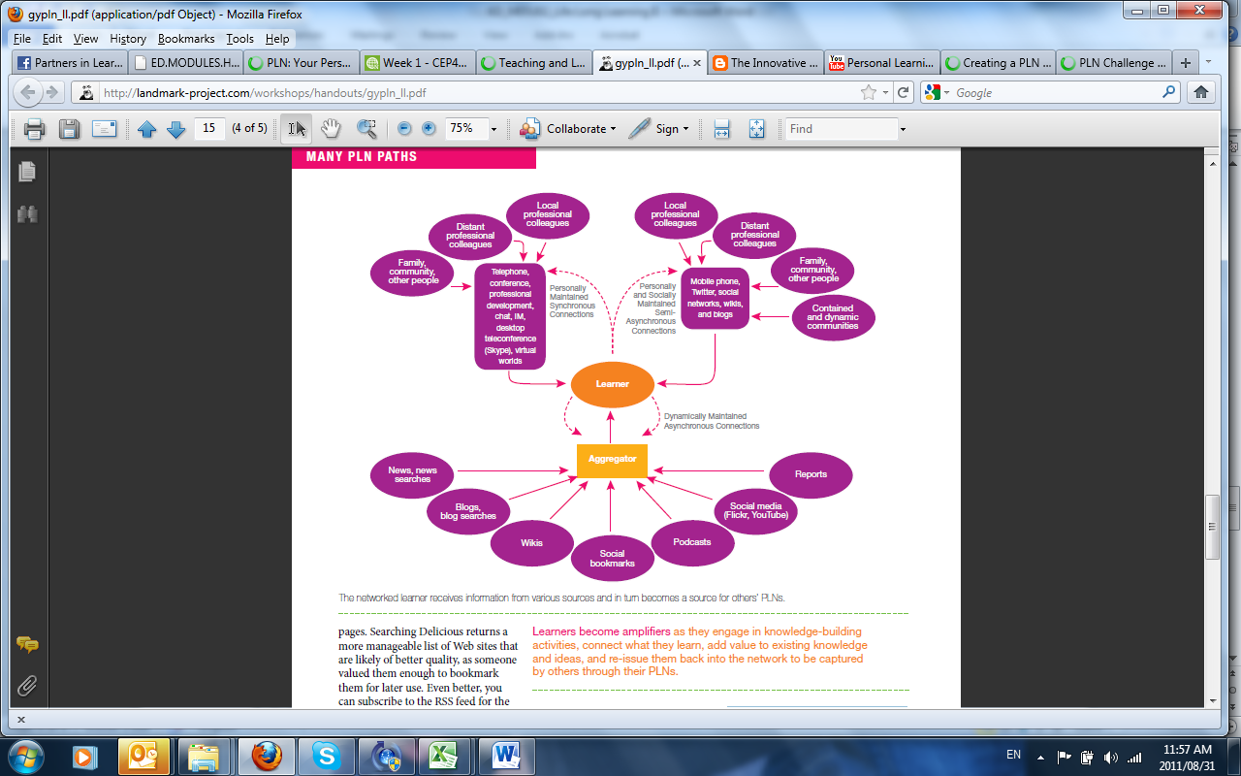
[Image Source: http://landmark-project.com/workshops/handouts/gypln_ll.pdf]

Who should be in my Personal Learning Network?
The members in your network are not necessarily people with whom you liaise directly or know on a personal basis. The members of your network should be people, both inside and outside of your immediate circle, who have the knowledge that you are trying to master and who are willing to share their knowledge and experience with you.
How can a Personal Learning Network help me?
According to the blog, “Once a Teacher”, there are a number of benefits to establishing a Personal Learning Network:
- Professional development – learn from content-area specialists;
- Locate resources for your classroom, such as free websites and software;
- Get lesson plan ideas from master teachers;
- Learn about new technology and how to integrate it into your teaching;
- Find collaborative solutions;
- Find interesting links to education news.

How do I establish a Personal Learning Network?
If it is a very new concept to you, the trick is to start small. Ask other people in your group, or with whom you have gone through a training programme, to participate in periodic discussions and share experiences with each other. You will find that most people are more than happy to help and are honoured to be asked to share their knowledge and wisdom.
Building a Personal Learning Network is a two-way street and requires that you not only seek to learn from others, but that you also help others in the network learn. This applies even if you are a novice in a particular field. You will still have a valuable contribution to make to the network. Perhaps you read an article that might be of interest to others. Or perhaps you heard of an interesting upcoming conference. Share this information with others and if you attend, then circulate your notes and any papers you collect to other network members.
A personal learning network can be your most powerful learning tool, no matter what the subject.
Warlick provides 10 tips to help establish your own Personal Learning Network:

- Start small and limit the number of blogs you subscribe to.
- Organise your subscriptions by topic or job function.
- Organise folders in your aggregator based on how frequently you need to read them. Call one folder “Every day” and place in it blogs and other RSS feeds that you need to see every day. Call another one “Once a Week” and another one “Once a Month”.
- Give yourself permission to switch your PLN off every once in a while. While your computer is off, take a break and go for a walk or a bicycle ride, visit a neighbour, or tend your garden for a few minutes. It is also okay to ignore parts of your PLN when you need to.
- Scan! You may need to read only one in 10 of the blogs that come through, but that one will make you a better educator.
- Your aggregator can grow temporary limbs. If you are teaching a new unit, find sources that will help you prepare for it and subscribe to them. When you’ve learned what you need, sever the lines.
- Realise that your network is much larger than it seems. You are not just reading my blog, you are reading all of the blogs that I read and all of the blogs that those bloggers are reading.
- Invest some time, but don’t fret that it will take up all your time. According to David Jakes, it takes only 15 minutes a day to learn something new.
- You do not need to subscribe to dozens of educators’ blogs to learn how they are using VoiceThread. Instead, conduct a Google Blog Search for voicethread and subscribe to that search’s RSS feed.
- Some bloggers are very good connectors and filters. They read lots of information and then blog the gems. Look out for them!

 B] Computer Practical (2 hours)

Note to Facilitator
It is important to iterate to the students that there is no one way to build a PLN. Everyone has their own preferred networking tools. The purpose of the practical is really to provide guidance as to how to set up such a network and what tools are available. Ideally you want them to ‘follow’ someone who is an established education ‘icon’ but also interact with people who are good but perhaps not of celebrity status. It would also help if you could get your colleague lecturers to ‘tweet’ or post regularly for a few weeks so that students would get an idea about online networks and how they work in a non-linear fashion. Use the practical session to show off some of the tools and also to allow them to sign to start building a small network.

The class will need connectivity for this activity. Also try and use student expertise where it exists to extol any virtues of the popular networking services, especially Facebook and Twitter, where many will already have accounts.

Introduction
There is no one way to build a PLN. Everyone has their own preferred networking tools. The purpose of this practical is really to provide guidance as to how to set up such a network and what tools are available.

In setting up a PLN you really have two main concerns:
- What combination of networking tools will I use?
- Who should I include in my network?

Activity 1: Networking Tools (1 hour)
Spend an hour investigating the merits of the following tools. Where necessary subscribe to the any of the free services and try them out:

Wordpress or Edublogs (Blogs) | http://www.wordpress.com
Guide: http://teacherchallenge.edublogs.org/2011/07/04/pln-challenge-5-using-blogs-as-part-of-your-pln/
Twitter (Social networking) | http://twitter.com
Guide: http://teacherchallenge.edublogs.org/2011/06/21/pln-challenge-3-using-twitter-to-build-your-pln/
Diigo (Social bookmarking) | http://www.diigo.com/
Guide: http://teacherchallenge.edublogs.org/2011/07/12/pln-challenge-7-using-diigo-as-part-of-your-pln/
Wikispaces (Collaborative writing) | http://www.wikispaces.com/
Guide: http://teacherchallenge.edublogs.org/2011/05/10/free-tools-23-wikispaces/

Activity 2: Creating a Network (1 hour)
While all the tools above allow you to grow your network by interacting with different people, you also need to actively grow your network. Twitter, for example, allows you to both ‘follow’ and be followed. It’s a good idea to follow one or two education icons to see what they are doing. This is relatively easy to do as you subscribe to their username. For example, the British educationist, John Davitt, can be followed by linking to his Twitter username, @johndavitt. It makes sense, however, to follow someone you have heard at a conference or a lecturer whose perspective you enjoy. Start collecting some twitter accounts.

- Go online to http://twitter.com and create an account, if you have not already in the previous activity. Log in.
- Click on the ‘Who to Follow’ tab from the menu at the top of the screen.
- In the ‘Who to Follow’ search field, insert a phrase like ‘Teaching history’ that reflects your interest.
- A set of search results appears where numerous users are listed. Select one and their profile appears in the right hand panel. Look for the Tweet summary where you can see how many people that person is following and how many are following him or her. (Tip: People who have more ‘followers’ than they are ‘following’ tend to be more interesting… however, this is hardly a golden rule . You will also see that the results do not only list individuals. Some are organisations.)
- Select a few individuals and organisations to follow.
- Now look for a few of your student colleagues and lecturers by using the search facility.
- Accept all requests to be followed from your colleagues.
- Keep an eye on your home page in Twitter because it will list the tweets (posts) from your network.
- If you want to do more with Twitter, work through this presentation written by Derek Moore: http://www.slideshare.net/weblearning/microblogging-2419870.

Activity 3: Grow your Network (1 hour)
Networks take some time and effort to grow. They will not support you properly until they have a certain size and dynamism. In order to grow your networks, look at these resources for ideas.

- Creating a Personal Learning Network: http://www.dontwasteyourtime.co.uk/presentations/presentation-creating-a-personal-learning-network-pln/
- Grow your PLN: http://landmark-project.com/workshops/handouts/gypln_ll.pdf
- How’s your PLN: http://msmslearningcommunity.blogspot.com/2009/03/hows-your-pln.html
- Personal Learning Networks for Educators: http://www.youtube.com/watch?v=q6WVEFE-oZA
- Innovative Educator – Video: http://theinnovativeeducator.blogspot.com/2008/04/5-things-you-can-do-to-begin-developing.html
- Educators PLN: http://edupln.ning.com/

C] Self-Study (1 hour)

Notes to Student
For this activity, you will require access to an Internet-connected computer with high-speed connectivity.

You can use your networks in a very structured way to achieve a learning objective. The MOOC or Massive Open Online Course is a proper course but one that utilises the fluid nature of social networks as a channel for learning. Enrolment is huge, hence the word ‘massive’ but the learning that takes place can be just as effective if not better than the traditional lecture. Let us find out more about MOOCs.

Activity:

- Watch the following three online videos pertaining to MOOCs (Massive Open Online Courseware):
  - What is a MOOC: http://www.youtube.com/watch?v=eW3gMGqcZQc
  - Knowledge in a MOOC: http://www.youtube.com/watch?v=bWKdhzSAAG0&feature=related
  - Success in a MOOC: http://www.youtube.com/watch?v=r8avYQ5ZqM0&feature=related
- Now visit the site http://mooc.ca to investigate what MOOCs are in process at this time. It might be a bit much to complete a course now as you are already studying education, but consider its design. Is there a way you could incorporate parts of its design into your own teaching?

Resources Used in this Lesson Unit

Warlick, D. (2009). Grow Your Personal Learning Network: New Technologies Can Keep You Connected and Help You Manage Information Overload. Available at http://landmark-project.com/workshops/handouts/gypln_ll.pdf (© All rights Reserved).

Commier, D. (2010). What is a MOOC? Available online at YouTube http://www.youtube.com/watch?v=eW3gMGqcZQc. Accessed 23/08/2011 (CC: BY).

Commier, D. (2010). Knowledge in a MOOC. Available online at YouTube http://www.youtube.com/watch?v=bWKdhzSAAG0&feature=related. Accessed 23/08/2011 (CC: BY).

Commier, D. (2010). Success in a MOOC. Available online at YouTube http://www.youtube.com/watch?v=r8avYQ5ZqM0&feature=related. Accessed 23/08/2011 (CC: BY).

Moore, D. (2011). Microblogging on Twitter. Available online at Slideshare http://www.slideshare.net/weblearning/microblogging-2419870. Accessed 01/09/2011 (© Free to use online).

Weisberger, C; Butler, S. Presentation: Creating a Personal Learning Network #PLN. Available online at: http://www.dontwasteyourtime.co.uk/presentations/presentation-creating-a-personal-learning-network-pln/ Accessed 10/10/2011 (CC: BT: SA).

PLN: Your Personal Learning Network Made Easy. Available online at Once a Teacher Blog: http://onceateacher.wordpress.com/2009/05/05/pln-your-personal-learning-network-made-easy/. (Accessed 23/08/2011) (© Free to use online).
Teacher Challenges. (n.d.). Teacher Challenges. Available at Edublogs at http://teacherchallenge.edublogs.org. (© Free to use online.)

Creating a PLN (n.d.). Teacher Challenges. Available at Edublogs at http://teacherchallenge.edublogs.org/challenges-2/creating-a-pln/. (© Free to use online.)

What is a PLN, anyway? Available online at http://www.teachingvillage.org/2009/09/10/what-is-a-pln-anyway/comment-page-1/. (© Free to use online.)

http://clintlalonde.net/2009/10/08/on-historically-defining-personal-learning-network/
David Warlick. (2009). Grow Your Personal Learning Network: New Technologies Can Keep You Connected and Help You Manage Information Overload. Available at http://landmark-project.com/workshops/handouts/gypln_ll.pdf.
David Warlick. (2009). Grow Your Personal Learning Network: New Technologies Can Keep You Connected and Help You Manage Information Overload. Available at http://landmark-project.com/workshops/handouts/gypln_ll.pdf.
http://onceateacher.wordpress.com/2009/05/05/pln-your-personal-learning-network-made-easy/
David Warlick. (2009). Grow Your Personal Learning Network: New Technologies Can Keep You Connected and Help You Manage Information Overload. Available at http://landmark-project.com/workshops/handouts/gypln_ll.pdf.

